Mini Project Report
Project title | The Rotten Tomatoes Gap: Quantifying the Critic vs. Audience Disconnect
Student name(s) and register no. | Anushka Sinha – 245816322  Aahna Negi – 245816190
Programme, semester and section | B.Tech (Data Science), Sem __, Sec B
Teacher guide / guardian | [Name, Department]
Duration and date of submission | [Start date – End date]

1. Abstract
Rotten Tomatoes reports two scores for every film, one from professional critics and one from audiences, and they often disagree. This project measures that gap across 17,407 films using a public Kaggle snapshot of the site (October 2020). The data was cleaned in Python, a rating gap was computed for each film, and 951,814 critic reviews were scored with the VADER sentiment model. Results are shown in an interactive Streamlit dashboard. Average scores of the two groups are almost equal, yet a typical film differs by about 17 percentage points, and the direction of the gap depends on genre.

2. Problem Statement and Objectives
- Problem: a single headline score hides how often, how much and in which direction critics and audiences disagree about a film.
- Clean and validate the critic and audience ratings and quantify the rating gap (critic % − audience %) for every film, overall and by genre.
- Score the text of critic reviews with sentiment analysis and check how review tone relates to both scores.
- Build an interactive dashboard for searching films, ranking the largest disagreements and comparing up to five films side by side.

3. Methodology
Dataset: Stefano Leone’s Rotten Tomatoes Movies and Critic Reviews dataset (Kaggle, CC0), with 17,712 films and about 952,000 critic reviews, scraped on 31 October 2020. Tools: Python, pandas, VADER (vaderSentiment), Plotly, Streamlit, Parquet and unittest.
A preprocessing script downloads the data with KaggleHub, renames columns, converts ratings to numbers (invalid or out-of-range values become missing, never zero), parses release dates and splits genres. It then computes the rating gap and its absolute size for each film, removes empty and duplicate reviews, and gives each review a VADER compound score labelled Positive (≥ 0.05), Negative (≤ −0.05) or Neutral. The cleaned tables are saved as Parquet files that the Streamlit dashboard loads and caches. Twenty-four automated tests check the pipeline, filters, charts, data snapshot and the running app.
Kaggle CSVs → Cleaning and validation → Rating gap → VADER sentiment → Parquet → Dashboard

4. Results and Discussion

4.1 Analysis results
Table 1: Key results from the processed dataset (pp = percentage points)
Measure | Result
Films with both critic and audience scores | 17,407 of 17,712
Critic reviews scored with VADER | 951,814 (17,697 films)
Mean critic score / mean audience score | 60.7% / 60.6%
Mean absolute gap (median) | 16.9 pp (14 pp)
Films with a gap of 20 pp or more | 34.7%
Critics higher / audiences higher | 54.2% / 43.8%
Correlation between critic and audience scores | r = 0.65
Review tone: positive / neutral / negative | 59.4% / 13.9% / 26.7%
Correlation of mean review tone with critic / audience score | r = 0.41 / 0.35
On average the two groups agree almost exactly, but individual films do not: the typical film differs by about 17 points and one in three by 20 points or more. The direction follows genre. Audiences rate Kids & Family (−4.6 pp), Action & Adventure (−3.7 pp) and Comedy (−3.3 pp) higher, while critics favour Documentary (+7.7 pp), Classics (+7.3 pp) and Horror (+5.2 pp). Review tone tracks the critic score more closely than the audience score, as expected since the text is written by critics, and “Fresh” reviews average a compound score of 0.31 against 0.02 for “Rotten” ones.

4.2 Implementation
The dashboard has four tabs (Overview, Movie Detail, Compare and About the Data) and a sidebar whose search and filters apply to all of them. Figures 1–6 were captured from a live run of the app.
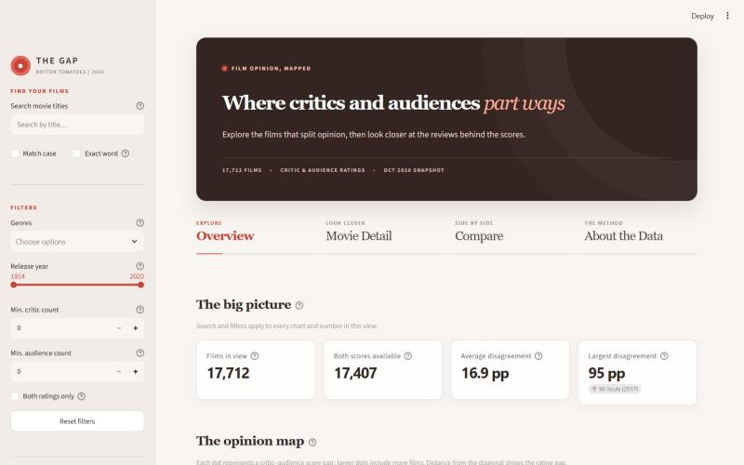  Fig. 1: Overview – headline figures, filters and tabs | 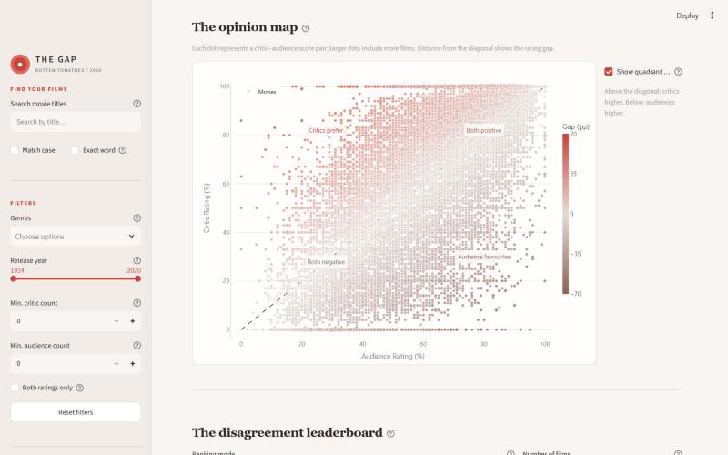  Fig. 2: Opinion map – critic vs. audience score per film
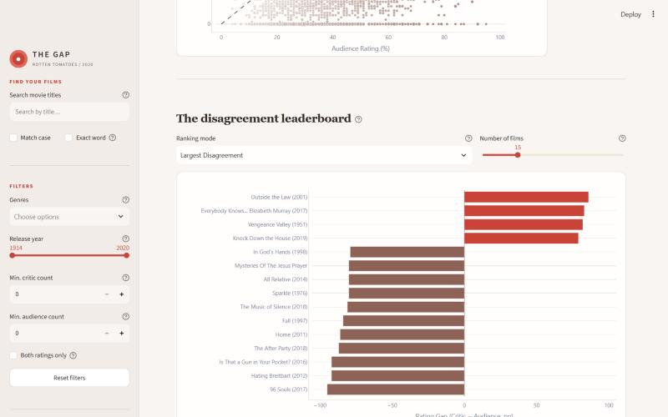  Fig. 3: Disagreement leaderboard by rating gap | 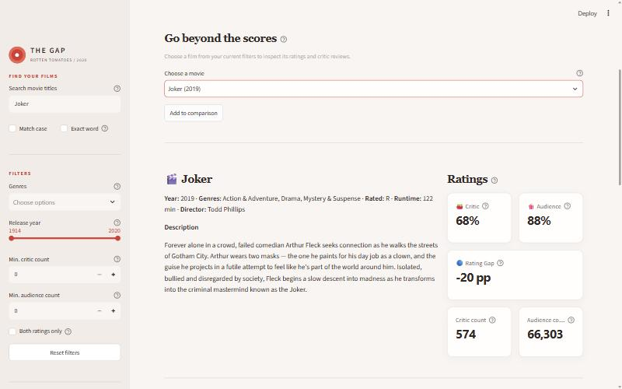  Fig. 4: Movie Detail – Joker (2019), 68% vs. 88%
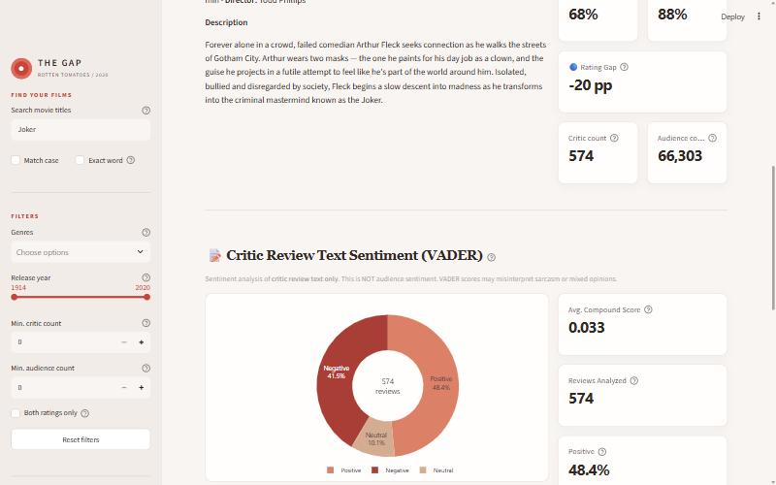  Fig. 5: VADER sentiment of Joker’s 574 critic reviews | 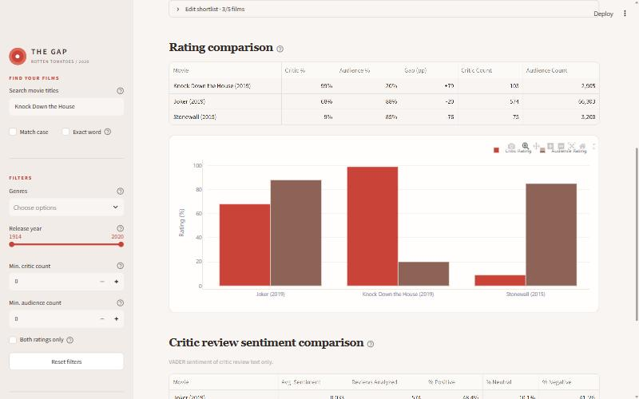  Fig. 6: Compare – three films side by side

4.3 Testing
Table 2: Test summary
Test level | What was checked | Result
Unit tests (unittest) | Data cleaning and validation, VADER scoring, filters, charts and the integrity of the bundled data snapshot | 17 / 17 passed
Headless app tests (Streamlit AppTest) | Search and match options, every filter, reset, ranking modes, film selection, review filters, the five-film comparison limit, remove and clear | 7 / 7 passed
Live run in the browser | All four tabs and the search → detail → compare flow; browser console and server log | No errors

5. Conclusion and Future Scope
The project delivers a tested data pipeline and a Streamlit dashboard with title search, a critic-vs-audience scatter plot, gap rankings, per-film sentiment, a review explorer, side-by-side comparison and CSV export. It shows that the critic–audience gap is large for individual films even though the averages match. Limitations: the data is a 2020 snapshot, VADER can misread sarcasm, no audience review text is available, and the two scores come from different groups of reviewers. Next steps are to replace VADER with a transformer-based sentiment model trained on film reviews, and to refresh the data with newer releases and audience review text.

6. References
- S. Leone, “Rotten Tomatoes Movies and Critic Reviews Dataset,” Kaggle, 2020.
- C. J. Hutto and E. Gilbert, “VADER: A Parsimonious Rule-based Model for Sentiment Analysis of Social Media Text,” Proc. 8th Int. AAAI Conf. on Weblogs and Social Media (ICWSM), 2014.
- W. McKinney, “Data Structures for Statistical Computing in Python,” Proc. 9th Python in Science Conf. (SciPy), 2010.
- Streamlit, “Streamlit Documentation,” docs.streamlit.io, accessed October 2026.
Student signature | Guide signature | HOD signature

